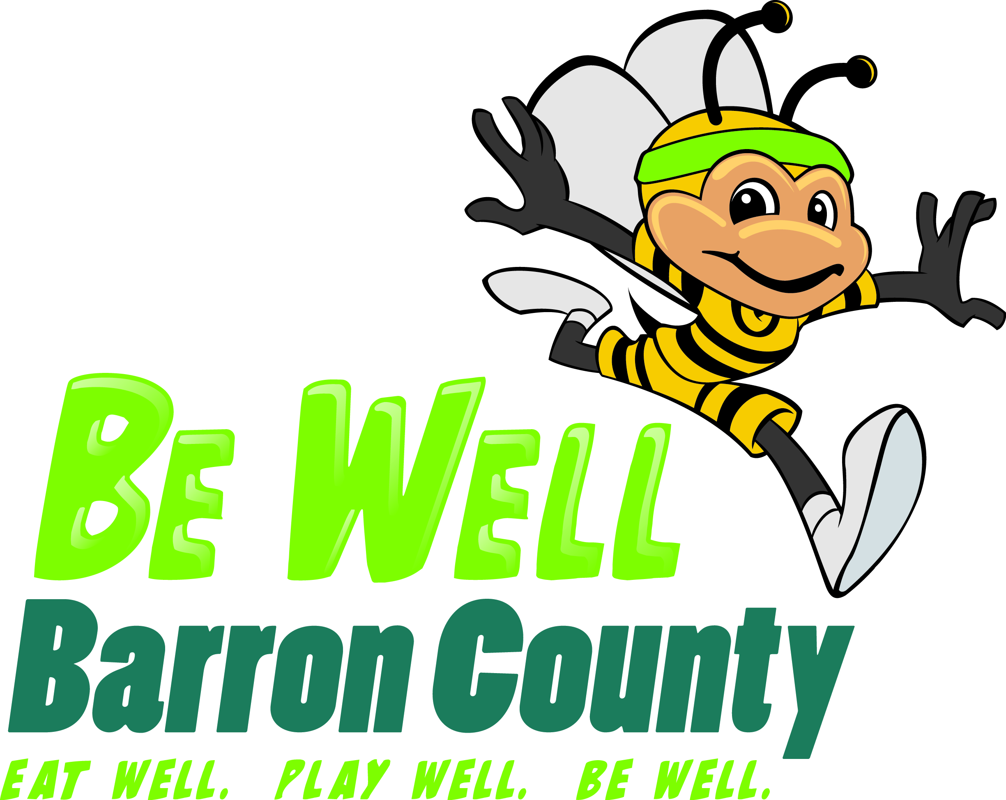
Be Well’s Fall into Wellness!
Calendar & Tracker (Page 1)

October 2012
www.BeWellBarronCounty.org Laura Johnson, 715-537-6120

Sunday | Monday | Tuesday | Wednesday | Thursday | Friday | Saturday
 | 1 | 2 | 3 | 4 | 5 | 6
Email Week 1 Point Totals!  ______/5  ______/35 | Week 1  ______/5 | ______/5 | ______/5 | ______/5 | ______/5 | ______/5
7 | 8 | 9 | 10 | 11 | 12 | 13
 | Week 2  ______/5 | ______/5 | ______/5 | ______/5 | ______/5 | ______/5
14  Email Week 2 Point Totals!  ______/5  ______/35 | 15 | 16 | 17 | 18 | 19 | 20
 | ______/5  Week 3 | ______/5 | ______/5 | ______/5 | ______/5 | ______/5
21  Email Week 3 Point Totals!  ______/5  ______/35 | 22 | 23 | 24 | 25 | 26 | 27
 | ______/5  Week 4 | ______/5 | ______/5 | ______/5 | ______/5 | ______/5
28  Email Week 4 Point Totals!  ______/5  ______/35 | 29 | 30 | 31 | Keep track of your points and if you get 21 or more, report each week for prizes! You’ll also report total points to bewellchallenge@gmail.com on or before November 19th. The tracker is for your own benefit, and does not need to be turned in.
 | Week 5  ______/5 | ______/5 | ______/5
Be Well’s Fall into Wellness!
Calendar & Tracker (Page 2)

November 2012
www.BeWellBarronCounty.org Laura Johnson, 715-537-6120
Sunday | Monday | Tuesday | Wednesday | Thursday | Friday | Saturday
Keep track of your points if you get 21 or more, report each week for prizes! You’ll also report total points to bewellchallenge@gmail.com on or before November 19th. The tracker is for your own benefit, and does not need to be turned in. |  |  |  | 1 | 2 | 3
 |  |  |  | Week 5  Cont…  ______/5 | ______/5 | ______/5
4  Email Week 5 Point Totals!  ______/5  ______/35 | 5 | 6 | 7 | 8 | 9 | 10
 | Week 6  ______/5 | ______/5 | ______/5 | ______/5 | ______/5 | ______/5
11  Email Week 6 Point Totals!  ______/5  ______/35 | 12 | 13 | 14 | 15 | 16 | 17
_____/210
Challenge Ends!
18 | 19 | 20  Submit Total Number of Points before this date! | 21 | 22 | 23 | 24
25 | 26 | 27 | 28 | 29 | 30 | 31
Be Well’s Fall into Wellness!

Fall 2012 (page 3)

Bonus Points:

1 bonus point available per day:

- Meatless Monday
  - Don’t eat meat on Monday, and try vegetarian meals instead!

- Trim Tuesday
  - Get an extra 30 minutes of exercise.

- Well Wednesday
  - Do a stress-relieving activity.

- Thirst-quenching Thursday
  - No pop or power drinks today.

- Fresh & Fruity Friday
  - Add one extra fruit or vegetable to each meal.

- Strong Saturday
  - Do one strength training activity.

- Smoke-Free Sunday
  - Be tobacco free! Don’t use tobacco or be in a place that has secondhand smoke.

Daily Point Challenge:

- 1 point: Eat breakfast
- 1 point: Drink 4-6 glasses of water
- 1 point: Get at least 7 hours of sleep the night before
- 1 point: Eat a fruit or vegetable with every meal
- 1 point: Get at least 30 minutes of exercise
Total of 5 points each day!

To find additional tips, information or ideas, check out BeWellBarronCounty.org and Be Well Barron County on Facebook.

Questions? Contact
Laura Johnson at 715-537-6120.

Be Well’s Fall into Wellness!
You could win: Athletic equipment, kayak, outdoor & fitness gear, healthy cooking supplies, gift certificates, gym memberships, mp3 players, yard games, bikes, DVD’s, and much, much more!

Fall 2012 (page 4)
Rules

- This challenge is for ages 1 to 100+!!

- Please be honest when calculating points.

- Earn points by following the Daily Point Challenge.

- This calendar and tracker is for your use. You do not need to turn it in. Only point totals, name, age and phone number need to be turned in.

- Including bonus points, you may be able to get up to 6 points per day. To be entered into weekly prize drawings, you must have a minimum of 21 points per week.

- Any participant with 21 points or more must turn in points each Sunday to be entered into weekly prize drawings. Check the calendar for dates. Please submit name, age, phone number and point totals to bewellchallenge@gmail.com. You may also mail them directly (postmarked by the following Monday):
Laura Johnson
Be Well Barron County
335 E Monroe Ave, Room 338
Barron, WI 54812

- Weekly prize winners will be announced the week after totals are due, on the Be Well Barron County website and Facebook page. The grand total of points must be turned in by November 19th. Grand prizes will be awarded by the end of November.

- Grand prizes will be awarded to the top two adults and two children with the most total points (if tie, winner will be drawn). Any participant with over 175 total points will be entered into additional prize drawings!

- Grand prize winners will also receive money for their workplace or school wellness program!

- Like us on Facebook at Be Well Barron County, or check out the website, www.BeWellBarronCounty.org for tips, info and prizes winners!

